TOWN OF FOUNTAIN HILLS, ARIZONA

MISSION STATEMENT

The Town of Fountain Hills’ purpose
is to serve the best interests of the community by:
providing for its safety and well-being;
respecting its special, small-town character and quality of life;
providing superior public services;
sustaining the public trust through open and responsive government;
and maintaining the stewardship and preservation of its
financial and natural resources.

This page left intentionally blank.

Fountain Hills Town Council

Mayor Wally Nichols
Vice Mayor Jay Schlum
Councilmember Mike Archambault
Councilmember John Kavanagh
Councilmember Edwin Kehe
Councilmember Keith McMahan

In Memory of Vice Mayor Kathleen Nicola

Management Staff

Timothy G. Pickering, CEcD, ICMA-CM, Town Manager

Department Directors

Julie Ghetti, MPA, CPA, CGFM, Finance Director
Ted Armbruster, Town Magistrate
Mark Mayer, Director of Parks, Recreation, and Community Center
John Kleinheinz, Sheriff Captain
Thomas Ward, Director of Public Works, Building Safety and Planning
Mark Zimmerman, Fire Chief

FOUNTAIN HILLS TOWN COUNCIL
2005-2006

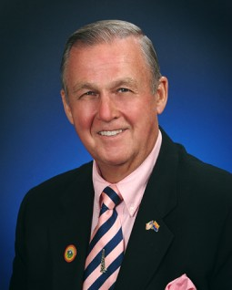
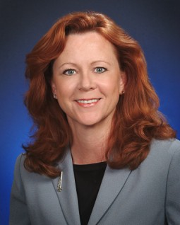
Vice Mayor Mike Archambault

Councilmember Keith McMahan
Wallace J. Nichols was elected Mayor of Fountain Hills in May 2003. Mr. Nichols has served in highly regarded positions throughout his career; such as Executive Director for WorldatWork (formerly ACA), Managing Director for Nichols & Wharton, Inc., Senior Vice-President Human Resources at Premark International, Inc., Vice-President of Compensation & Benefits for Dart & Kraft International, Inc. and Director of Compensation & Benefits for CPC International, Inc. He was educated at Tufts University, earning a Bachelor’s degree in Economics, and is an alumnus of the Harvard Business School. He has served the community as an elected officer/Chairman of the Fountain Hills Sanitary District, Los Arcos Multipurpose Facilities District Board of Directors, Scottsdale Boys & Girls Club Board of Directors, Fountain Hills Boys & Girls Club Advisory Chairman, Chairman of the Fountain Hills Community Center Advisory Commission, and on the Citizens Committee/Community Benefits Committee Board. Other local affiliations include the Noon Kiwanis, Fountain Hills Chamber of Commerce, Friend of the Fountain Hills Community Theater, Senior Center, Civic Association, Library Association, Republican Club, Fountain Hills Historical Society, McDowell Park Association, and the Four Peaks Community Church.

Vice Mayor (past)
Kathleen Connelly Nicola
Mayor
Wally Nichols
A long-time Arizona resident, Vice Mayor Kathleen Connelly Nicola moved to Lake Havasu City in June 1967 and her family settled in Fountain Hills in 1989. Kathleen passed away suddenly on May 19, 2005.
Kathleen earned a Bachelor of Science degree in Justice Studies from the College of Public Programs at Arizona State University. Kathleen graduated from the Arizona School of Real Estate & Business, and made a career change in the summer of 2000 to become a licensed real estate salesperson. Her license currently hangs with John Hall & Associates in Scottsdale.

Kathleen was a member of the Fountain Hills Chamber of Commerce and the Scottsdale Association of Realtors.

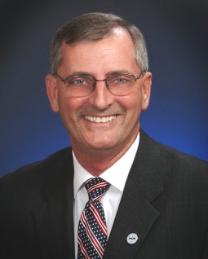
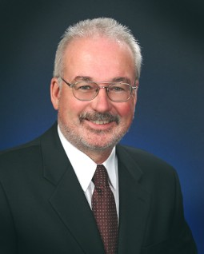
Councilman Mike Archambault moved to Fountain Hills from Columbus, Ohio in 1972. He built one of the first homes in Fountain Hills and was among the first 10 families to live here. In 1981, he started Fountain Hills Wood Whims, Inc., a custom cabinet shop that currently employs fifteen craftsmen. Mike and his crew have been providing custom cabinets for Valley builders for more than 20 years.

Mike has been involved in community services since he moved here in 1972. He ran annual “Secret Santa” programs, bringing toys to children and helping with food donations for needy families, served as a Cub Scout and Boy Scout leader, and a Leader for Order of the Arrow, graduating fourteen Eagle Scouts. Mike also helped with the drive to bring the first health clinic to Fountain Hills in 1977. He served on the Church of the Ascension Committee, and with the help of volunteers, Mike built the Church’s rectory. He also helped construct the original town library (now the Fountain Hills Theatre) with the Contractors Association, and assisted in building the Sunset Kiwanis clubhouse. He also served the community as President of the Fountain Hills Youth Association, and as a member of the Sunset Kiwanis.

John Kavanagh is a ten-year resident of Fountain Hills who is a professor of criminal justice at Scottsdale Community College and Director of the college’s Administration of Justice Studies Program. Prior to teaching at Scottsdale Community College, John taught at Arizona State University and spent 20 years as a police officer with the Port Authority of New York and New Jersey Police.
John Kavanagh has a B.A. in Sociology from NYU, an M.A. in Public Administration from St. John’s University (Queens, New York), and a Ph.D. in Criminal Justice from Rutgers University. He also belongs to professional associations, such as the American Society of Criminology and the Arizona Criminal Justice Educators Association.
John Kavanagh is serving or has served with the following town groups: Parks and Recreation Commission, Community Center Advisory Committee, Vision 2000 Planning Committee, School Board Calendar Committee, Youth Basketball League, Veterans Memorial Sitting Committee, the Knights of Columbus, Civic Association, and the American Legion.
Councilmember
John Kavanagh
Councilmember
Mike Archambault
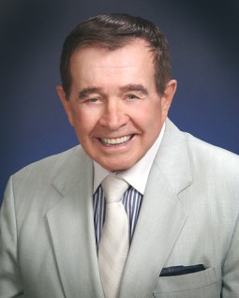
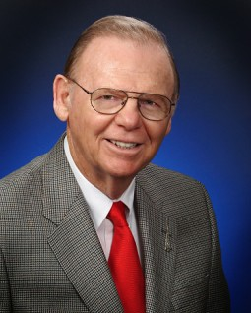
Ed Kehe was awarded the degrees of Bachelor of Arts with honors by Albion College (MI) and Master of Science by the University of Illinois. In addition he earned sixty post-degree graduate credits and certificates in administration and directorships.

His career spanned thirty-three years in public secondary education, teaching mathematics, physical education, and coaching interscholastic sports. Ed retired in 1984 from White Plains (NY) High School after fourteen years as Director of Athletics. He served leadership roles at the local level, statewide, and nationally in both his professional and private life.

Ed and wife Dolores moved to Fountain Hills in 1995. He volunteers with Home Delivered Meals; was a hospitality usher at Church of the Ascension; worked for the passage of the original mountain bond issue; serves on the boards of the McDowell Park Association and the Golden Eagle Foundation; is a member of Noon Hour Kiwanis, Senior Activity Center, Civic Association, Republican Club, River of Time Museum; as well as a friend of the Community Theater and Chamber of Commerce.

Keith McMahan moved to Arizona in 1971 as an advertising writer with Lorne Pratt Enterprises, Inc., the ad agency for McCulloch Properties until 1991 when he formed his own company, McMahan and Company Advertising Agency. Keith has been actively involved in community projects and organizations since he came to Fountain Hills. He was the advertising and tourism chairman for the Chamber of Commerce for nine years as well as serving on their Board of Directors for three years. In 1997, he was honored as the "Business Person of the Year" by the Chamber of Commerce.
He served as an elected member of the Fountain Hills School Board from 1986 to 1990. For nine years, he was on the Road District Joint Powers Board; chairman in 1978. He is presently a contributing member of several organizations: the Fountain Hills Civic Association, the Fountain Hills Republican Club, and the Fountain Hills Historical Society Board of Directors.

Councilmember
Keith McMahan
Councilmember
Ed Kehe
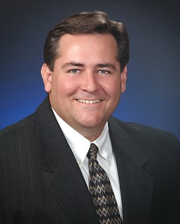
Jay Schlum moved to Fountain Hills 27 years ago and he attended Coronado High School in Scottsdale. After graduation he attended Northern Arizona University where he studied Business Management and Public Speaking. After college, he returned to Fountain Hills and is currently employed by Qwest Communications where he manages business development for the company.

Jay has been active in the Fountain Hills community - he served as a Fountain Hills Planning and Zoning Commissioner, PTA vice president and is actively involved with the local Community Theater. Jay volunteers and performs in productions. He has also served on the advisory committee for the Boys and Girls Club of Fountain Hills.

Presently Jay is the president of the Shepherd of the Hills Lutheran Church and a coach with the Fountain Hills Little League.

Vice Mayor
Jay Schlum

DEMOGRAPHICS

The Town of Fountain Hills is a planned, family-oriented community established in 1970 by McCulloch Properties (now MCO Properties, Inc.). Prior to 1970 the area was a cattle ranch and was part of one of the largest land and cattle holdings in Arizona. It was purchased by Robert McCulloch in the late 1960s and designed by Charles Wood, Jr. (designer of Disneyland in southern California). The centerpiece of Fountain Hills is one of the world's tallest man-made fountains, a focal point that attracts thousands of visitors each year. Located on 11,340 acres of land, and bordering northeast Scottsdale, Fountain Hills is surrounded by the 3,500-foot McDowell Mountains on the west, the Fort McDowell Indian Reservation on the east, the Salt River Indian Reservation on the south and by the McDowell Mountain Regional Park on the north. Elevation is 1,520 feet at the fountain, 3,000 feet on Golden Eagle Boulevard, and is 500 feet above Phoenix.

Over the past thirteen years Fountain Hills has grown from 10,190 residents to a town of over 22,000 in 2004. The Maricopa Association of Governments (MAG) estimates that the population of Fountain Hills will continue to grow to near 25,000 by 2010. Although the rate of growth has slowed due to the national economy the Town continues to attract residents who are building large custom homes to take advantage of the scenic vistas surrounding our mountain community.

The Town offers a range of living styles, from small community subdivisions to a number of large custom homes. Fountain Hills also offers recreational, cultural and retirement programs that address the needs and lifestyles of active families and adults. The community consists of primarily residential property with a total of 11,700 acres. Of the total available land 8,706 acres are developable, 460 acres are zoned commercial or industrial (approximately 5%) and 3,600 acres are reserved as open space (30%).

Government and Organization

The Town of Fountain Hills is an Arizona Municipal Corporation, acting as a general law Town as prescribed in the Arizona Revised statutes. The Town was incorporated on December 5, 1989 with the governmental and administrative affairs of the Town operating under the Council-Manager form of government. The Town Council is responsible, among other things, for the adoption of local ordinances, budget adoption, the development of citizen advisory committees and hiring the Town Manager. The Town Manager is responsible for implementation of the policies of the Town Council and administering the Town’s operations through five department directors and approximately 81.5 employees. The Magistrate, Town Attorney and Town Prosecutor are under the direction of the Town Council.

Fountain Hills Community Center

Assessed Valuation of Major Taxpayers

MAJOR EMPLOYERS
Town of Fountain Hills, Arizona

Approximate
Employer Product/Service Employment

Fountain Hills Unified School District No. 98 Education 250
Monks Construction Construction 150
Safeway Food Stores Grocery Store 95
MCO Properties, Inc. Property Management 85
Town of Fountain Hills Government 75
Basha’s Grocery Store 70
Sun Ridge Canyon Golf Course Golf Course 70
Fountain Hills Concrete Mfg. Ready-Mixed Concrete 50
Golf International Golf Course 50
Eagle Mountain Golf Course Golf Course 40

Source: The 2004 Arizona Industrial Directory; Greater Phoenix Chamber of Commerce; Community Profiles Arizona Department of Commerce; and an individual employer survey.

Employers

Residents of the Town can find employment in neighboring Scottsdale, the Fort McDowell Indian Community, or the municipalities that make up the greater Phoenix metropolitan area.

POPULATION STATISTICS

Town of Maricopa State of
Years Fountain Hills County Arizona

2005 Estimate* 23,700* 3,524,175 5,832,150
2000 Census 20,235 3,072,149 5,130,632
1995 Special Census 14,146 2,551,765 4,228,900
1990 Census 10,190 2,122,101 3,665,339
_____________________

* Estimated population as of July 1, 2005

Source: U.S. Census Bureau.

UNEMPLOYMENT AVERAGES

Town of Maricopa State of United
Years Fountain Hills County Arizona States

2004 2.2% 4.0% 4.8% 5.5%
2003 2.7 4.9 5.6 5.6
2002 3.1 5.6 6.2 6.0
2001 2.2 3.9 4.7 4.8
2000 1.4 2.6 3.9 4.0

Source: Arizona Department of Economic Security, Research Administration.

Table of Contents

Budget Overview ▬▬▬▬▬▬
Budget Transmittal Message 1
Council Goals 2
Fiscal Year 2004-2005 Financial Accomplishments 4
Budget Process 9
Financial Policies 15
Budget Schedule 27

Budget Summary ▬▬▬▬▬▬
All Funds Revenue and Expenditure Summary 29
General Fund Revenues 45
General Fund Expenditure Summary 54

Department Budgets ▬▬▬▬▬▬
Town Council 55
Administration 59
Operational & Community Support 67
Information Technology 71
Public Works 77
Building Safety 87
Streets 93
Planning 101
Parks and Recreation 107
Parks 115
Community Center 127
Public Safety
Law Enforcement 133
Fire Department 137
Municipal Court 141

Schedules/Summaries ▬▬▬▬▬▬
Special Revenue Funds 147
Debt Retirement 151
Development Fees 157
Capital Projects 163
Summary of Tax Levy and Tax Rate Information 165
Schedule of Fountain Hills Assessed Valuation 166
Schedule of Authorized Positions 167
Succession Plan 171
Glossary 177

Appendix ▬▬▬▬▬▬
Personnel Requests A
Community Requests B
20 Year Financial Overview C

